**Objective**

In this project 6 point model has been used to implement the Djikstra’s Algorithm. The diagram for 6 point weighted and directed path is as follows:

A

C

B

E

D

F

Each path depicted in above diagram has some defined value which is specified in a certain direction. For an instance if considering source as A then the weights related to A are AB and AC. This notion is applied to every vertex. Corresponding weights related to above vertices are:

AB-2 CE-3 ED-1

AC-5 EF-3 BE-5

BC-3 BD-4 DF-1

These mentioned weights are used to find the immediate adjacent element with the shortest path.

**Working of Code**

In this project for implementing Djikstra’s Algorithm in assembly language macros and procedures are used for various intended tasks. The purpose and significance of Macros is mentioned in comments in the code. Working of this code is split in various macros. The code mentioned in above link has following parts:

* Main Code
* Display Procedure
* Comparison Macros
* Final Matrix Display Procedure

Main code consists of all the necessary macro calls, procedure calls and data declarations. It also Display Procedure has looping involved in it, main intention of this procedure is to display the weight matrix. Weight matrix is used in the code to store the evolving values of the weights of vertices. After comparing the weights of adjacent vertices with respect to current source the value of weights is updated in weight matrix.

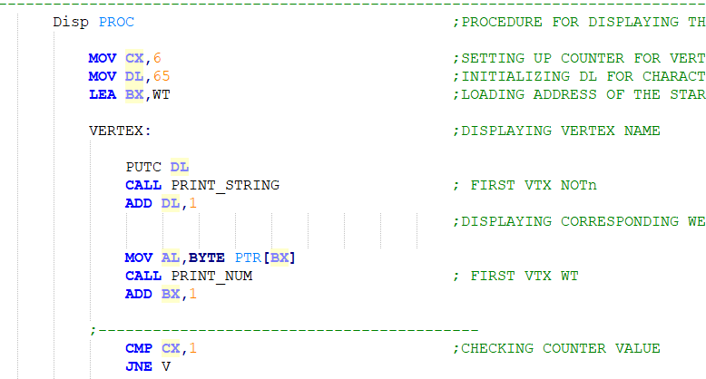

Comparison Macros are defined to compare the weights of the adjacent vertices from the current considered source. Main intention of comparison macro is to find the shortest adjacent vertex i.e to select least weighted path.

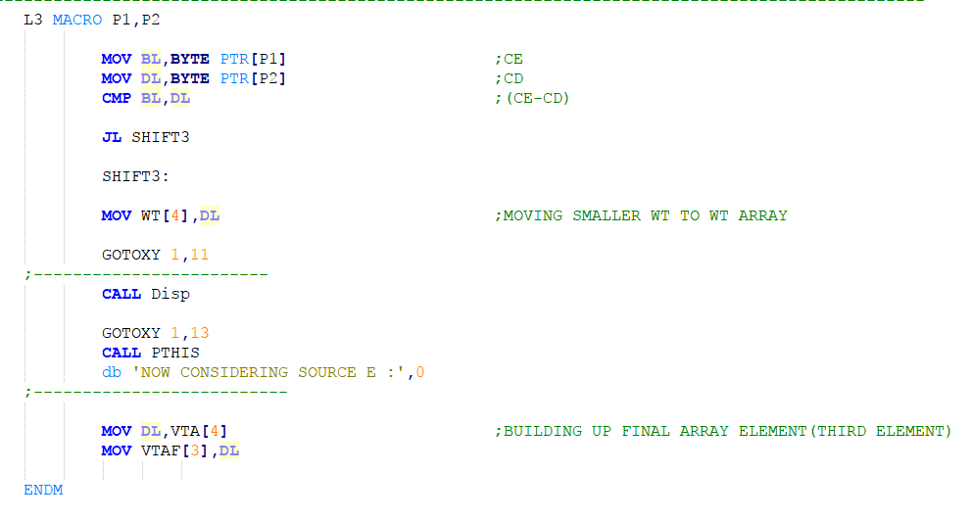

One more procedure defined in this code is Final Matrix Display Procedure. It is defined to display the final resultant path. After all the computation the final deduced path is stored in a final array matrix, this matrix is continuously updated during source selection and weight comparison. Final matrix Display proc aids in displaying available and the deduced single source shortest path